**ASSIGNMENT 2**

Q1. Find the names of all branches in loan relation.

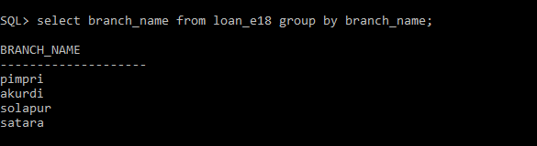

Q2.Find all loan numbers for loans made at Akurdi Branch with loan amount > 12000.

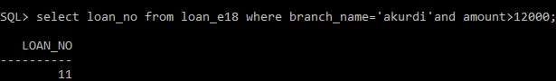

Q3. Find all customers who have a loan from bank. Find their names,loan_no and loan amount.

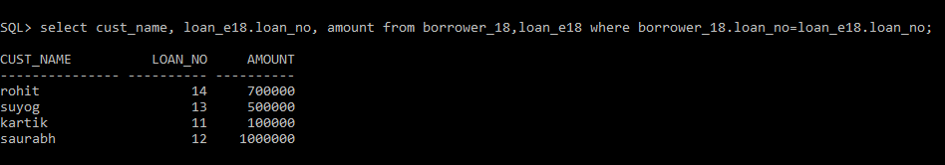

Q4. List all customers in alphabetical order who have loan from Akurdi branch.

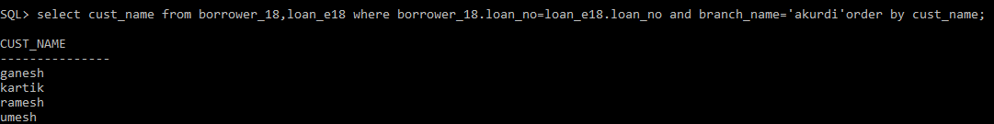

Q5. Find all customers who have an account or loan or both at bank.

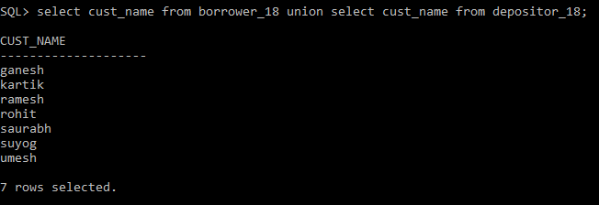

Q6. Find all customers who have both account and loan at bank.

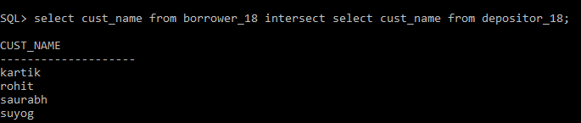

Q7. Find all customer who have account but no loan at the bank.

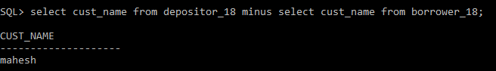

Q8. Find average account balance at Akurdi branch.

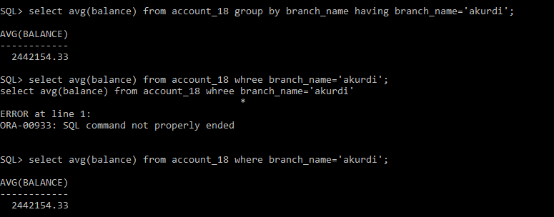

Q9. Find the average account balance at each branch

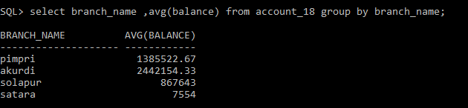

Q10. Find no. of depositors at each branch.

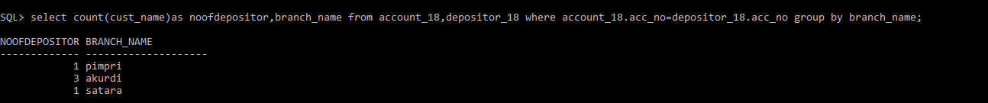

Q11. Find the branches where average account balance > 12000.

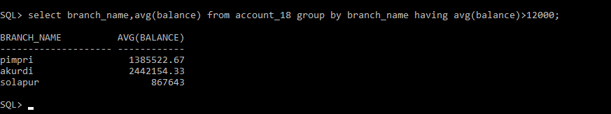

Q12.Find number of tuples in customer relation.

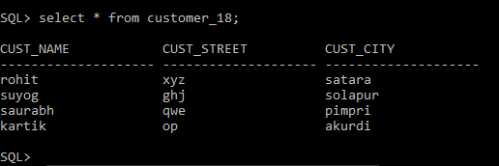

Q13. Calculate total loan amount given by bank.

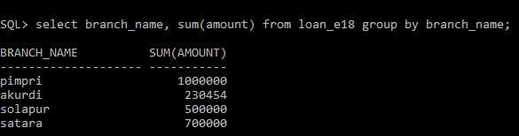

Q14. Delete all loans with loan amount between 1300 and 1500.

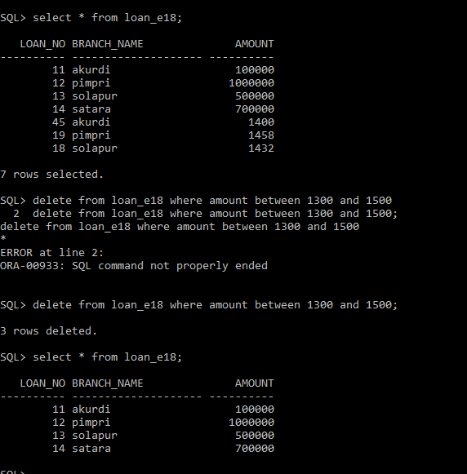

Q15. Delete all tuples at every branch located in Nigdi

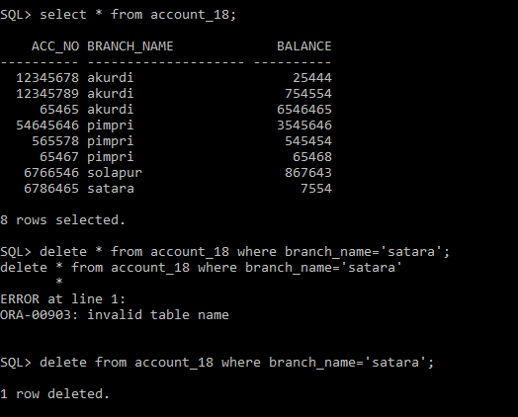

Q.16. Create synonym for customer table as cust.

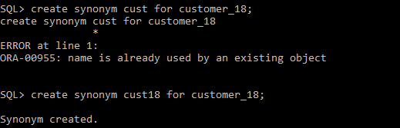

Q.17. Create sequence roll_seq and use in student table for roll_no column.

